**Stages of development:**

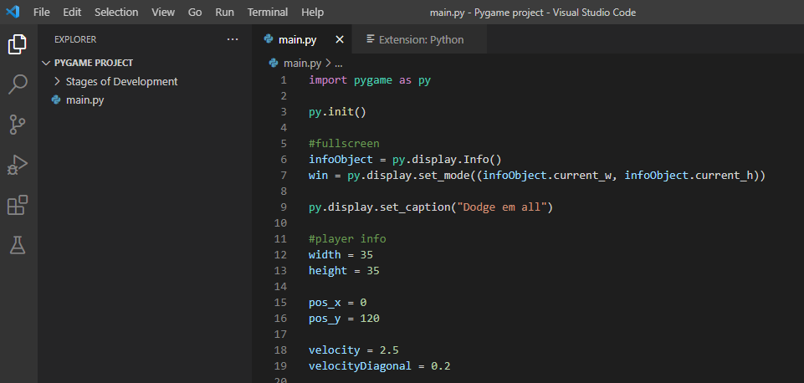

Importing pygame library and setting up variables such as fullscreen and player attributes.

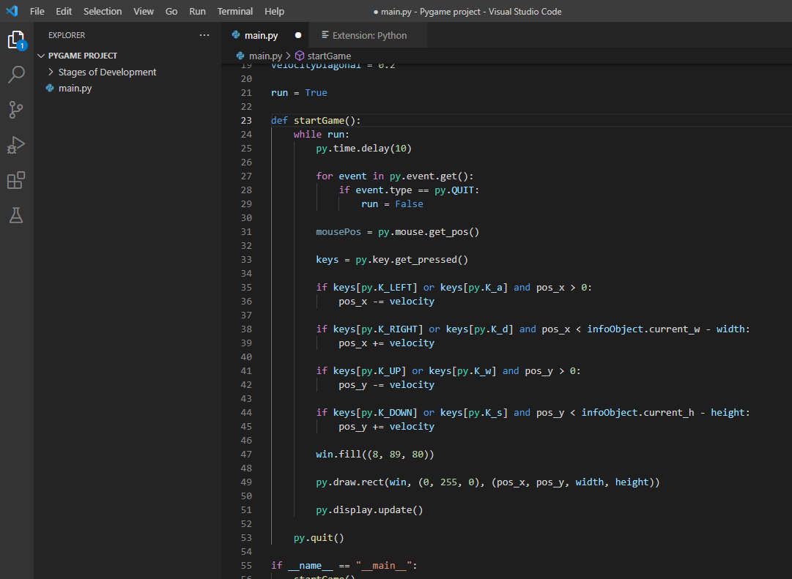

Starting the pygame window for the main game, this is put into a function so that it can be run from the main menu (when I make it). I added player controls so that the player can move around.